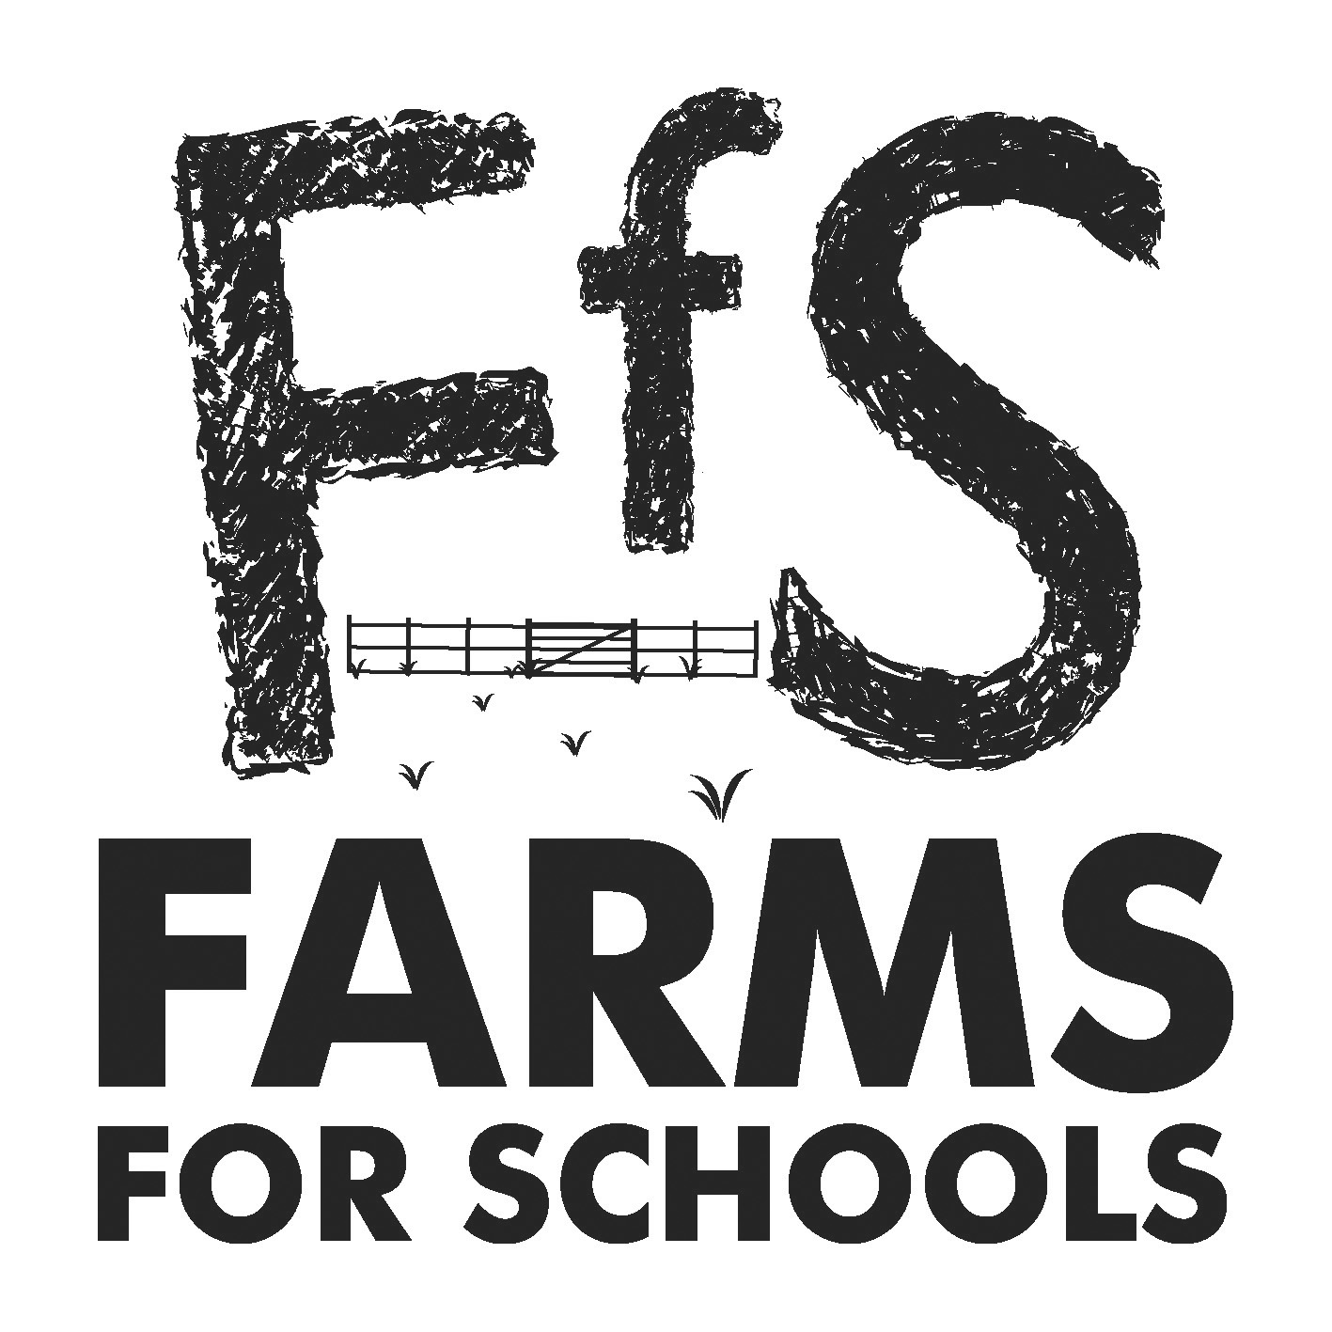 | Farms for Schools  Membership Renewal Form  Membership valid until end of 2022 | 
To become a member of Farms for Schools please complete this form so we can include your details on the Farms for Schools website and know that you are complying with the Charter of Good Practice. If you have CEVAS accreditation and/or an LOtC Quality Badge then please let us know on page 3 so we can include in your webpage details. Make sure to add your social media account details below, so we can share your posts.
Once we have received the form we will send out an invoice for your membership fee. Please email the completed form to info@farmsforschools.org.uk
Name of Farm: ______________________________________________________
Parent/farm group name if different: ____________________________________
Contact Name for bookings/enquiries: __________________________________
Main SITE address where schools will visit/arrive:
___________________________________________________________________
___________________________________________________________________
Post Code: ____________________________________________
Telephone: ____________________________________________
E-mail: ___________________________________________________
Website:__________________________________________________
Facebook:_________________________________________________
Twitter:___________________________________________________
Email address for renewal of membership i.e. accounts department:
___________________________________________________

Number of visitors annually? _____________________
Do you have disabled access to a significant part of your farm? If yes, please describe below:
YES |  | NO

Please provide us with a brief description of your farm below (Please limit your entry to 50 words).
_______________________________________________________________
_______________________________________________________________
_______________________________________________________________
_______________________________________________________________
_______________________________________________________________

Type of farm: which one best describes you (please tick ONE box only)
Livestock farm (livestock/mixed) |  | Farm visitor centre/working museum
Arable farm |  | School or college farm
Horticultural unit |  | City farm

Main enterprises that visitors can see/experience: (please tick ALL that apply)
Beef/suckler cows |  | Pigs |  | Arable
Dairy |  | Poultry |  | Horticultural (including nurseries)
Sheep |  | Goats |  | Forestry/woodland management
Fish |  | Horses |  | Small/pets
 |  |  |  | Other

Other: please state below

Are you CEVAS Accredited? |  | 
Farm accredited?  Farmer(s) accredited?
  YES |  | NO
  YES |  | NO

Do you have The Learning Outside the Classroom (LOtC) Quality Badge?
 | 
  YES |  | NO
Main facilities suitable for: (please tick ALL that apply)
Pre-school visits |  | Baby changing area
Primary school visits |  | Toilets for disabled visitors
Secondary school visits |  | Teachers pack
Further education visits |  | Coach Parking
Guided tours |  | Cafe
Free pre-visit for teachers |  | Shop
Open all year (most months) |  | Picnic Area
Seasonal visits only |  | Indoor play area
Wet weather facilities (adequate for 40 people) |  | Outdoor play area

Booking requirements: (please tick ALL that apply)
All visitors must pre-book |  | All groups must pre-book |  | There is an entrance charge

Charter of Good Practice
As a member of Farms for Schools I declare that:-
1 | These premises have been and will be inspected by:
 | a) | The Health and Safety Executive in accordance with local policy.
 |  | My local HSE Office is:
 | b) | The Environmental Health Office in accordance with local policy.
 |  | My local Environmental Health Office is:
2 | The farm has livestock, which is attended by a veterinary surgeon at least once every 12 months.
 | My veterinary surgeon is:
3 | I possess current public liability insurance.
 |  | Name of Insurer:
 |  | Certificate No:
4 | Sufficient car/coach parking is available.
5 | Sufficient toilets and hot and cold running water and soap are available.
6 | Undercover facilities are available for wet weather.
7 | The farm will inform Farms for Schools of any major situation concerning health and safety, public health or overall reputation of the farm.
8 | The Charter of Good Practice will be displayed at the premises.
9 | I declare that we agree and adhere to the new Industry Code of Practice – please tick
Membership charges for 2022 are staying at £95 per annum for admission charging farms and £45 per annum for non-admission charging farms. However, if paid by 31 December 2021 you will receive a discount of £15, so the payments will be £80 and £30 respectively. Please select one of the following options:

Fee Charging Farm = £80/£95
Non-fee Charging Farm = £30/£45
To the best of my knowledge all the information included on this form is correct
(please tick the box)
Name: _______________________________Date:_________________
PLEASE MAKE YOUR CHEQUE PAYABLE TO “COUNTRYSIDE LEARNING”
Or if you prefer to pay by BACS, please transfer payment to
The Countryside Learning Bank Account at Unity Bank 20274890 Sort Code 60-83-01
Thank you for your membership renewal.
Farms for Schools, PO Box 8, Hebden Bridge, HX7 5YJ
Tel: 07711 069092 E-mail: info@farmsforschools.org.uk www.farmsforschools.org.uk

